Welcome to


About us
Transpiral Wellbeing Pty Ltd is a mental health and well-being focussed NDIS provider based in Adelaide, South Australia. We provide high quality, evidence based mental health education, counselling, support coordination and personal care. We believe that mental well-being is at the centre of living life well.
We work within our values of:
- We Listen Deeply. You are heard. Your opinions are valued. We listen not just to hear what you are saying, we listen to understand. We listen with our ears, but also with our hearts.
- Presence. You have our focus. When we are with you, we are fully present to you, with no distractions, interruptions, or devices.
- Empathy. Empathy is our superpower. Empathy is the thread that connects us to one other and allows us to share the incredibly healing message that ‘you are not alone.’
- Trust. Confidentiality is everything.
- Truth. We value truth, speak with integrity, and keep our promises.
- Excellence. We will always do our best.
- Passion. We love what we do, and we are blessed to do what we love
We commit to
- Providing support that’s all about you and what you want
- Finding the right staff for you
- Providing the best service, we can
- Respecting you and protecting your rights in everything we do
- Listening when you tell us how to make our services better
Your rights
- Have someone read through this booklet with you  - Be respected  - Not have anything bad happen to you  - Choose the support you want and need  - Have help to make choices  - Be told if your service needs to change | - Have access to supports that respect your lifestyle, your culture, and your religion  - Have a copy of your service agreement and support plans  - Have your right to privacy promoted and protected  - Feel safe to tell us if you’re not happy or make a complaint  - Choose a person to speak on your behalf if you wish
What you need to do
- Respect the workers and other staff  - Tell us what we need to do better  - Give your worker 24 hours’ notice if you want to cancel your service  - Know your workers can only be there for your agreed service time. | - Tell us straight away if something needs to change about your plan or service  - Have all that we need for your service at your house, this helps us support you best
Support planning
We will help you to make a support plan for how and when you want your supports to be delivered. The plan will tell us what you want and need. Your plan belongs to you. Family members, friends and advocates can help you plan if you want them to.
Your privacy
We will only ask you about what we need to know to provide the best possible service. We only share what you have told us with people that work for our service and will ask for your consent before share information with anyone else. There may be times when the law requires us to share your information without your consent. For example, if there is a serious threat to safety or we are directed to do so by a court.
We will ask for the following information about you:
- Name, address, and phone number
- Age, gender, and disability
- Cultural, religious and language background
- Medical history
- Living arrangements
- Details about your work or day activities (only if relevant to supports we provide to you)
- Interests such as hobbies and sport
- Support needs such as communication, mobility, diet, assistive equipment/technology
- Information we need to know to keep you and others safe
- The law states that we need to ensure everything you tell us safe and private. We keep your information on paper and electronically on our business computers.
Our policies to ensure your information is kept secure include:
- We only collect information that helps us deliver supports safely to you.
- Only staff who need to know your information have access to it.
- Paper files are stored securely in lockable filing cabinets.
- We use password protection and two factor authentication when logging into software on our computers.
You can ask to see what information we hold about you at any time, including how we store your information. If you want to see or update your information, or you think we have breached your confidentiality, please contact the Managing Director Rae-Anne Holloway on 0408 333 831.
Safety in your home
If we are supporting you at home, we need to check that your house is safe, so that we know your workers will be safe. If it’s not safe for our workers, we will need to talk with you about this and find another way to provide your supports. Sometimes we might have to say ‘no’ to what you ask if it puts workers in danger.
The law says it must be safe for us to work together in your home. Some things that will help us are:
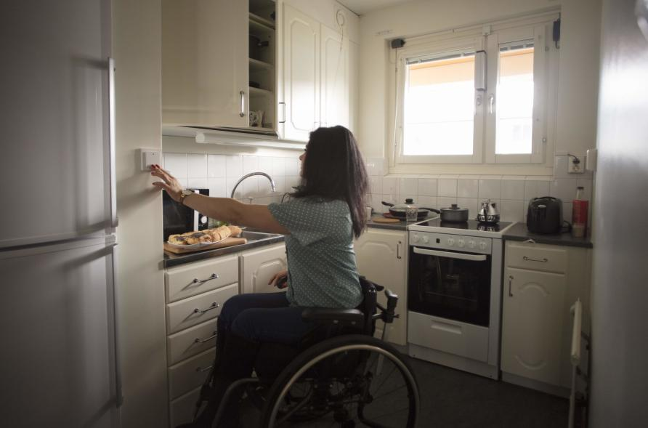
- Being there to help us check your home is safe and telling us if anything is unsafe in your home.
- Helping to fix things that aren’t safe
- Making sure your pets don’t hurt the workers.
- Not smoking when your workers are in your home.  - Making sure workers are safe from abuse of any kind.  - Making sure workers are respected.  - Telling our staff if you have an illness or infection that your workers might catch from you. | - Telling us if you are having chemotherapy or taking dangerous medications.  - Having safe cleaning tools and products for your workers to use.
We will do a safety check with you more than once just to make sure your home stays safe.
House keys and access codes
We will ask you to complete a form telling us that we can have a copy of your house key or access a code to enter your home when we provide support. You can change your mind at any time by letting us know in writing.
Advocates
An advocate is someone who will support you and speak on your behalf. An advocate can be a family member, friend, or someone from an advocacy service. You might like to have an advocate help you make choices. We can help you to get an advocate if you would like one.
Some things an advocate can do are:
- Support you when you have meetings with us or paperwork to fill in.
- Help you to know more about your choices, and help you make a final choice.
- Help you know what support you could have from other services.
- Help you to know your rights.
- Support you to tell us if you’re not happy with our services.
If you want or need the help of an advocate, you can find a list of organisations in your area at https://askizzy.org.au/disability-advocacy-finder.
Things to know about your service
When you decide that you would like to be supported by us, we need to agree how this will look. This is called a Service Agreement. The Service Agreement is between you and us. We both need to agree and to say yes to the rules about the service. If you say no, we will talk more to find another way. Your service agreement says what your rights are and what you have to do, and when and how we will support you. We will check your service agreement every year to see what needs to change, or you can ask to check it whenever you like.
If your worker is not doing their job or you are unhappy, don’t be afraid to tell us.
Our workers, or staff, have to follow rules. The rules are:
- No breaking the law or doing things for you that break the law.
- They only give you the service that your Service Agreement says they can.
- They can’t take money or gifts from you.
- If you have a will, they should not be in it.
- They can’t tell you what to do with your money, and they can’t look after your bank account
- They can’t buy things from you.

If you need to change your service time
Please tell us as soon as you know you need to change the time of your service. We will try to help with this if we can. Sometimes we won’t be able to change the time because other people need to have their service too. | 
If you change your service time you might get a different staff member.
Missing a service  Please tell your worker as soon as you know you won’t be there for your service. Please tell them the day before if you can. You might be able to have the service at another time.  If you are away from home  Talk to us if you need to stay away from home. Tell us as soon as you know this might happen. Please tell us straight away if you are moving house. We will need to talk about your service. |  | Stopping your service  You need to tell us straight away if your service needs to stop. If you go to hospital, you can stop your service until you come home again. If you’re in hospital for a long time you might need to change your service.  Please talk to your worker before you leave hospital.  If you are gone for three months and you don’t tell us why, we will stop your service.
What if my worker doesn’t show up?  If you have your worker’s number, give them a call to see where they are. You and your worker will have a plan for when this happens. Follow your plan if you need to. If you do not have a plan, wait 10 minutes and call our admin team on 0408 333 831 |  | What if my worker is doing something wrong?  If you feel okay to, tell them it’s wrong. Also, you can tell (insert contact details). Please don’t be scared to us if something is not right for you; we want to fix it. If your worker is breaking the law or abusing you, you can call the police.
How much will I pay?  Your service agreement will tell you how much your service costs. We will only charge in line with the NDIS price guide. These costs will be explained to you before you sign the agreement. You could have someone you trust look over the service agreement before you sign it. |  |  |   
What do I do in an emergency?  We will make a plan together about what to do in an emergency. Your workers or their manager will do their best to help you. If they can’t, they will call the person you have told us to call for you if there is an emergency. If we are worried for your safety and can’t get hold of you, we may call the police.   | What happens if I am hurt, or something goes wrong while I am receiving supports?  If you are hurt or an incident happens during your support shift, we will:  - ensure that you remain safe or support you to move to a safe location  - administer First Aid if required, or support you to access medical treatment  - let your chosen representatives, family member or guardian know  - write an incident report and investigate what happened and what went wrong  - talk to you about what you want to happen next  - put in place measures to prevent the problem from happening again  - let the NDIS Commission know if it is a serious and reportable incident.
How to give us feedback or make a complaint
We are happy if you or your family or carer tell us what’s going well or not going well about your service. You can tell us how it’s going by talking in person or by phone, writing a letter. You might tell us things that are going well, and things that are not good. We will listen to everything you tell us and try to fix it as best we can.
Also please tell us if you need an interpreter so we can speak with you in your language.

If you talk best in sign language, please tell us and we’ll find someone to help us talk together.
If we can’t help you with a problem and you’re unhappy about this, you can call someone who doesn’t work for us. For example,
- NDIS Quality & Safeguards Commission phone: 1800 035 544
- People with Disability Advocacy Service phone: 1800 422 015
We will keep all information private when helping you with a problem or complaint. We won’t change your service, unless there is a danger to you or your workers, until we fix the problem
How to contact us
Transpiral Wellbeing Pty Ltd
PO Box 284, Daw Park, SA, 5041
www.transpiral.com.au
0408 333 831
hello@transpiral.com.au
Please ensure the participant or their authorised representative sign on this page to confirm that we have explained the contents in this handbook.
The original copy will remain in this handbook and a copy will be held in the participant’s file.

Participant

I, ________________________________________ (your name)

have the Welcome Handbook and someone has helped me to read it.

Participant sign: ________________________________ Date: _______________

Transpiral Wellbeing Pty Ltd

Representative signature: ___________________________

Print name: _______________________________ Date: ____________

__ __ __ __ __ __ __ __ __ __ __ __ __ __ __ __ __ __ __ __ __ __

